**HYPOTHESIS TESTING**

1. A F&B manager wants to determine whether there is any significant difference in the diameter of the cutlet between two units. A randomly selected sample of cutlets was collected from both units and measured? Analyze the data and draw inferences at 5% significance level. Please state the assumptions and tests that you carried out to check validity of the assumptions.

**ANS:**

* H0 – null hypothesis : there is no significant difference in the diameter of the cutlet between two units.
* H1 – alternate hypothesis : There is a significant difference in the diameter of the culter between two units

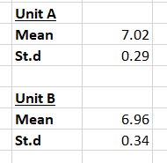

Z = $\frac{6.96-7.02}{0.29}$

Z = -0.21

P value from the z distribution table = 0.4168

since P value is greater than 0.05 significance level , null hypothesis is true

* therefore there is no significant difference in the diameter of the cutlet between two units.

A hospital wants to determine whether there is any difference in the average Turn Around Time (TAT) of reports of the laboratories on their preferred list. They collected a random sample and recorded TAT for reports of 4 laboratories. TAT is defined as sample collected to report dispatch.

Analyze the data and determine whether there is any difference in average TAT among the different laboratories at 5% significance level.

**ANS:**

**Null hypothesis H0** : there is no significance difference in average TAT among the different laboratories

**Alternate hypothesis HA** : there is a difference in average TAT among the different laboratories

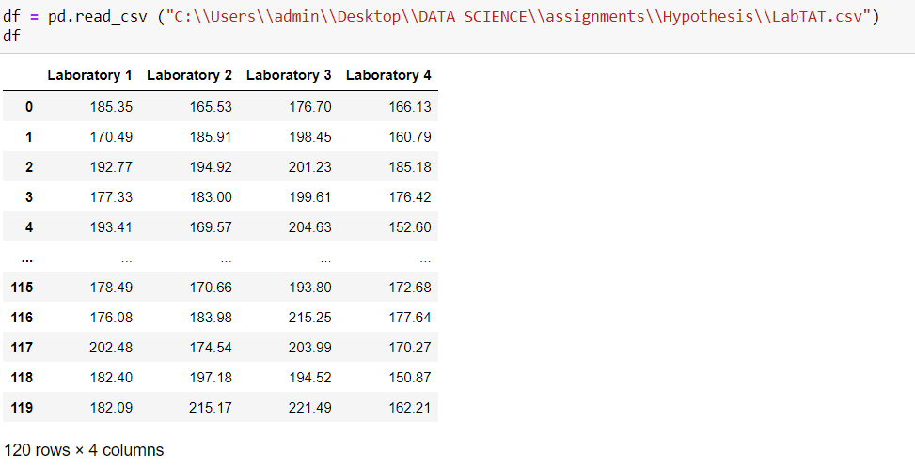

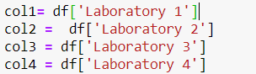

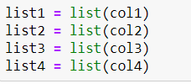





Since P value very much less than 0.05 significance level , Null hypothesis is rejected

Alternative hypothesis is true , : there is a difference in average TAT among the different laboratories

Sales of products in four different regions is tabulated for males and females. Find if male-female buyer rations are similar across regions.

|  |  |  |  |  |
| --- | --- | --- | --- | --- |
|  | **East** | **West** | **North** | **South** |
| Males | 50 | 142 | 131 | 70 |
| Females | 550 | 351 | 480 | 350 |

Buyer Ratio.mtw

**ANS:**

**Null hypothesis H0** : male-female buyer rations are similar across regions.

**Alternate hypothesis HA** : there is a difference in male-female buyer rations across regions.

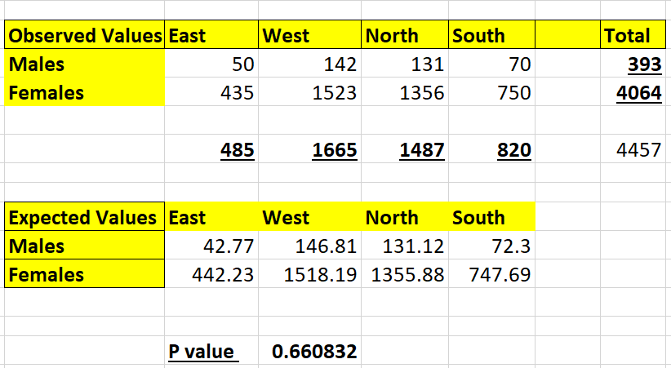

Using CHITEST function in EXCEL , P value is 0.66

Since P value is 0.66 , which is greater than 0.05 , Null hypothesis is true

Thus , male-female buyer rations are similar across regions.

TeleCall uses 4 centers around the globe to process customer order forms. They audit a certain % of the customer order forms. Any error in order form renders it defective and has to be reworked before processing. The manager wants to check whether the defective % varies by centre. Please analyze the data at *5%* significance level and help the manager draw appropriate inferences

Minitab File: **CustomerOrderForm.mtw**

**ANS:**

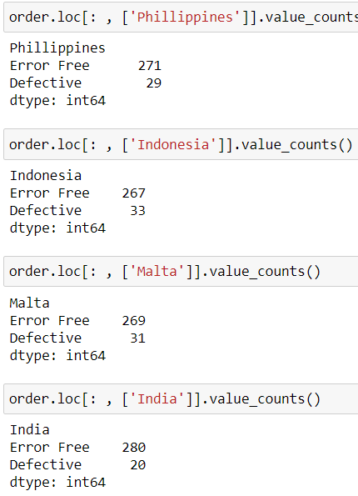

**Null hypothesis H0** : The defective % does not vary by centre

**Alternate hypothesis HA** : there is a difference in the defective % observed in each centre

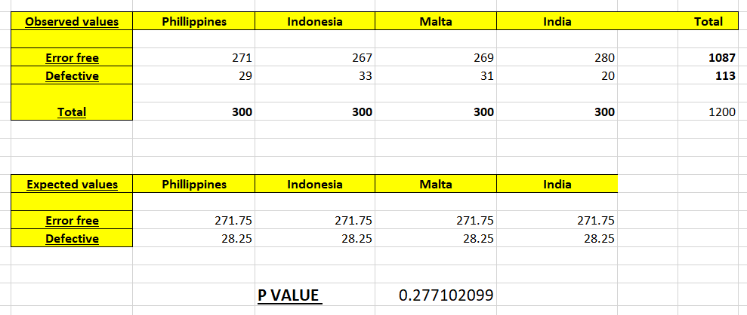

Using CHITEST function in EXCEL , P value is 0.28

Since P value is 0.66 , which is greater than 0.05 , Null hypothesis is true

Thus , The defective % does not vary by centre